**Network SQL Server Installation Guide**

**Version-2.0**

#### Document version control

|  |  |  |  |  |  |  |
| --- | --- | --- | --- | --- | --- | --- |
| **Sr. No** | **Date** | **Created/Modified by** | **Approved by** | **Section changed** | **Change description** | **Version number** |
| 1 | 1-Jan-2021 | Shreyas Nair | Nilesh Dhavare | NA | Initial Version | 1.0 |
| 2 | 1-Jan-2022 | Amol Bhagat | Nilesh Dhavare |  |  | 2.0 |

**SQL Server Installation Guide**

**For On-Prem Servers:**

* Check with infra team for Disk configuration.
  + All drives should be Thick Provisioning, Eager Zero.
* Check if the Disk allocation Unit is set to 64 kb.

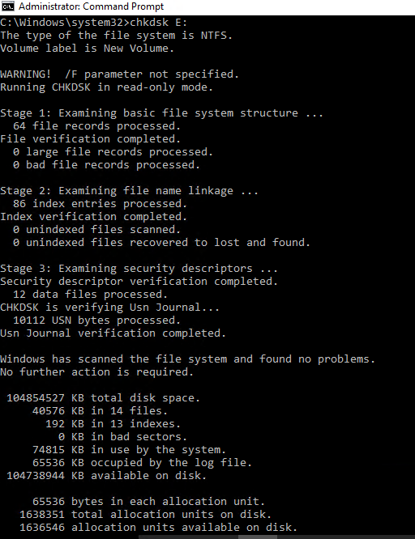

**For Azure Servers:**

* Check with infra team about Disk Configuration.(Premium SSD,HDD etc)
* Provide Disk Caching details as per best practice.  
  <https://docs.microsoft.com/en-us/azure/azure-sql/virtual-machines/windows/performance-guidelines-best-practices#disks-guidance>
* Provide Port list in case of AlwaysOn/SQL Replication configuration from Azure VM to On-Prem VM.
* **Disk Allocation Unit 64 K For all Drives**

|  |  |  |
| --- | --- | --- |
| **Assigned For** | **Disk Performance** | **Host Caching** |
| **Windows & SQL Installation** | High | **Read-writes** |
| **For Windows Pagefile** | High | **None** |
| **Tempdb LogFilesand User Database LogFiles** | High | **None** |
| **TempDB DataFiles and User Database Datafiles** | High | **Read Only** |
| **For other type of files** | Medium | **Read-write (default)** |

**SQL Installation**

* Add reliancecapital\sa_rgiclsqlservice on following local security policies
  + Adjust Memory Quotas for a Process.
  + Backup Files and Directories.
  + Bypass Traverse Checking.
  + Debug Programs.
  + Logon as a Service.
  + Manage Auditing and Security Logs.
  + Perform Volume Maintenance Tasks.
  + Replace a Process Level Token.
  + Lock pages in memory.
* Create following Folders and give reliancecapital\sa_rgiclsqlservice full rights on these folders
  + SQLDataFiles(For User Data Files)
  + SQLLogFiles(For User Log Files)
  + SQLTempDB(For SQL System Database TempDB)
  + SQLBackup(For SQL Database Backup)
* Select correct features and components as per ticket raised.
* Select SQL server Replication feature for PROD and Pre-PROD.  
  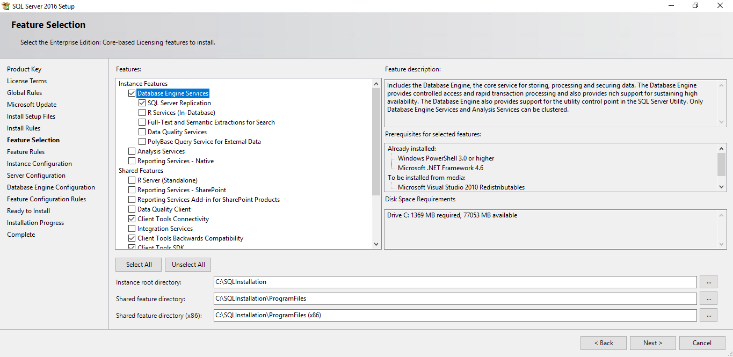
* Enter SQL Service Account and Passwords. Keep Startup type as automatic as per Screenshot.  
  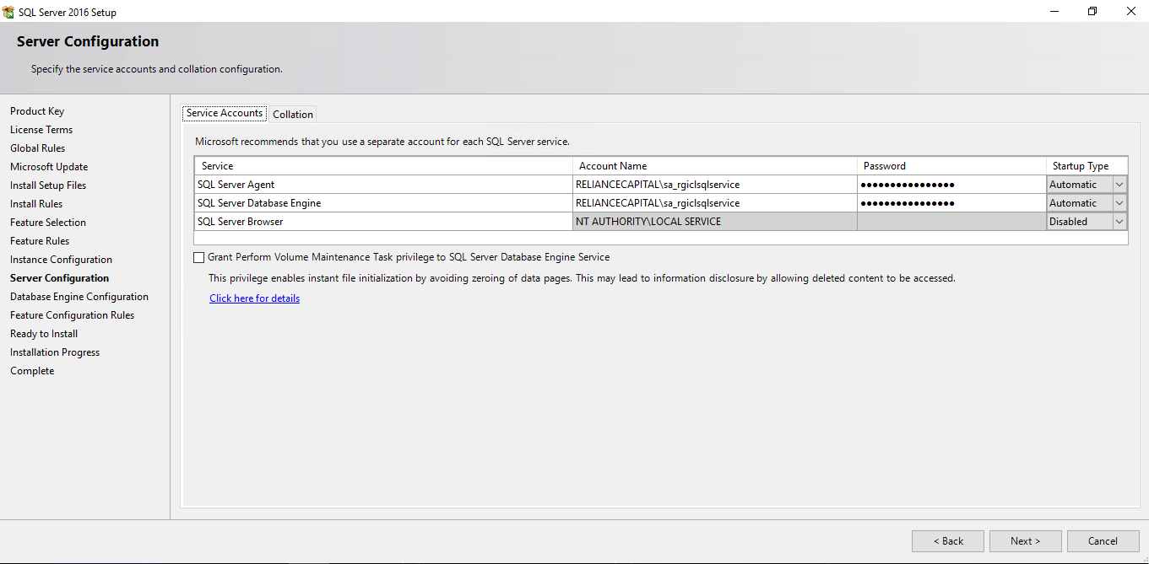
* Choose Domain Logins for SA privileges. SQL Server Authentication Mode: Mixed mode.  
  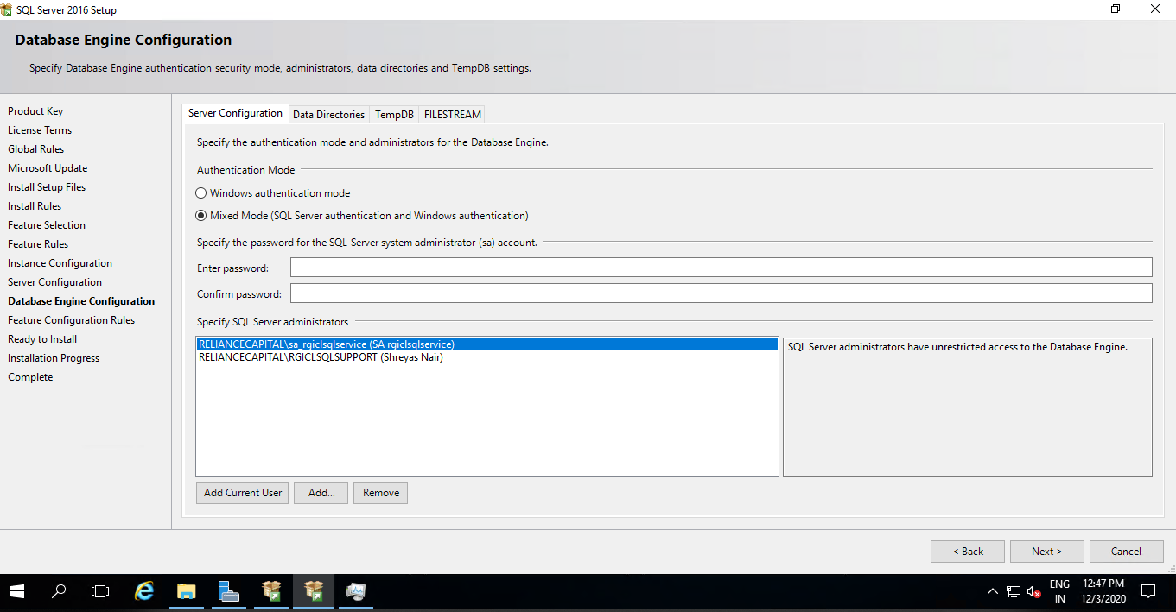
* Directories for Database files, SQL Database Backup and SQL System Databases:  
  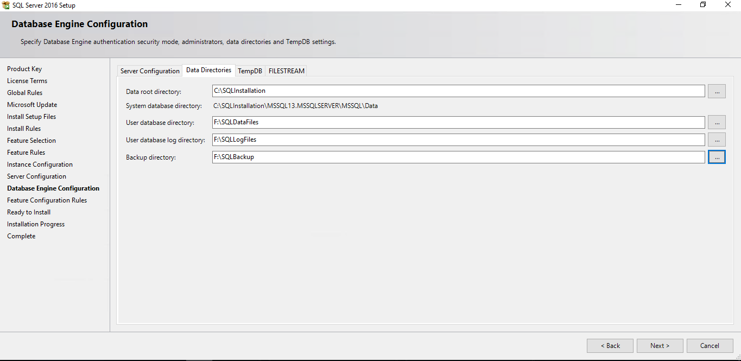
* Set SQL TempDB location, number of files, Size and its Auto growth details.  
  <https://docs.microsoft.com/en-us/sql/relational-databases/databases/tempdb-database?view=sql-server-2016>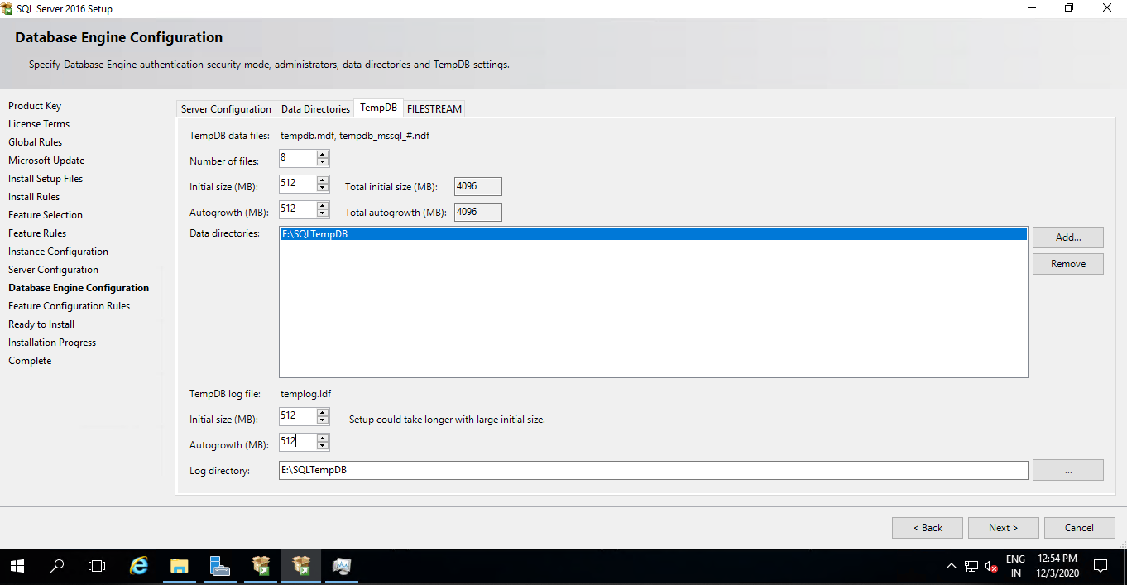
* Keep Initial size and autogrowth same for tempdb files.
* Install Latest Cumulative Update on the server.
* Install SQL Server Management Studio.
* Set Port for SQL Server to 7359.
* Create SQL User ‘dbateam’ and provide SysAdmin rights to the user.
* Disable SQL Login ‘sa’.
* Set configuration ‘OLE Automation Procedures’ to 1.
* Set configuration ‘xp_cmdshell’ to 1.
* Set configuration ‘Database Mail XP’s’ to 1.
* Set configuration ‘Backup Compression’ to 1.
* Set configuration ‘remote admin connections’ to 1. --to enable DAC.
* Set configuration ‘Max Server Memory (MB)’ to 75% of total Main Memory installed on Server.
* Set configuration ‘fill factor (%)’ to 80.
* Set configuration ‘optimize for ad hoc workloads’ to 1.
* Enable ‘Hide Instance’ option.
* Set PageFile.sys RAM value (RAM*1.5).—Let Infra Team to be decide it.
* Add SQL services running account in “**Lock pages in memory**” local policy.
* To Update Policies By running ( gpupdate /force ) command in Admin CMD.
* Configure MSDTC on PROD & PRE-PROD servers(Refer **DtcSettings** Doc for same).
* DB Mail Configuration.
* Create DBA Database DBAAdmin.
* Create Linked Server [RGISQL,7359] for Alert purpose. Use SQL Login mailuser.
* Create all DBA specific SQL Jobs.
  + DBA_Alert_tempdb_Above_25GB.
  + DBA_Daily_Report_new.
  + DBA_deadlock.
  + DBA_Diskspace_alert.
  + DBA_HighCPU_Utilization.
  + DBA_logspaceCheck.
  + DBA_Perfmon_Data.
  + DBA_SHRINK_LOGFILE.
  + DBA_SQL_Restart.
  + DBA_SQL_UPTIME_ALERT.
  + DBA_Temp_Db_Shrink.
  + DBA_Trac_Tempdb.
  + DBA_TraceFlag.
* Create SIEM Audit on server. (Refer any PROD Server)
* Create App SQL Logins as per team Calldesk ticket details approved by Nilesh Dhavare.
* Add user databases in backup policy as per team’s calldesk request in Veritas Net backup client (**On-Prem VM**), Azure Recovery Service Vault (**Azure VM**).
* Pls assure for user database autoshrink is off